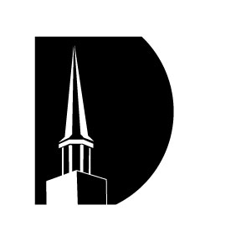

Milan Baptist Church

Frank Sherwin

Session 3

“Biology and the Age of the Earth”

February 25, 2018



Milan Baptist Church

Frank Sherwin

Session 3

“Biology and the Age of the Earth”

February 25, 2018