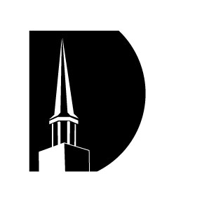

Milan Baptist Church

Frank Sherwin

Session 4

“The Fossil Record”

February 25, 2018



Milan Baptist Church

Frank Sherwin

Session 4

“The Fossil Record”

February 25, 2018